**El Espada**

**Programmer’s Manual**

**Prepared by the Avengers – UIS Force:**

**Avinash Moram**

**Daniel Henderson**

**Zach Parker**

TABLE OF CONTENTS

Requirements documentation 3

Introduction 4

1.1 Scope of the Product 4

1.2 Definitions, Acronyms, and Abbreviations 4

1.3 References 4

General Description 5

2.1 Product Perspective 5

2.2 Product Functions 5

2.3 User Characteristics 5

2.4 General Constraints 6

2.5 Assumptions and Dependencies 6

Specific Requirements 6

Design Documentation 24

High Level Flow Diagram 25

Entity Relationship Diagram 26

Activity Diagram 27

UML Diagram 28

Technical Document 29

Source Code Documentation 29

Testing documentation 29

known bugs and issues 30

**Requirements Documentation**

**Introduction**

* 1. **Scope of the Product**

The purpose of this project is to create a Windows-based software as a standalone application ready to take online orders for a Mexican restaurant. Throughout the development phase the utilization of the latest JDK, Maven, Spring Boot, H2 database, JavaScript, HTML, CSS, Thymeleaf, and Bootstrap to give the program a unique look. The software will have a unique user interface by displaying a pictorial menu with prices for each item and a summary page with the listed amounts per item. Easy-to-use payment methods to make the online experience much more user-friendly. We, the Avengers – UIS Force, feel confident that the use of the H2 in memory database should make the software easier to maintain in comparison to other databases.

**1.2 Definitions, Acronyms, and Abbreviations**

**1.3 References**

* **HTML -**<https://developer.mozilla.org/en-US/docs/Web/HTML>
* **CSS –** <https://developer.mozilla.org/en-US/docs/Web/CSS>
* **JavaScript –** <https://developer.mozilla.org/en-US/docs/Web/JavaScript>
* **BootStrap –** <https://getbootstrap.com/>
* **Spring Boot –** <https://spring.io/projects/spring-boot>
* **Maven –** <http://maven.apache.org/>
* **JPA Hibernate –** <https://hibernate.org/orm/>
* **H2 Database –** <https://www.h2database.com/html/main.html>
* **Thymeleaf –** <https://www.thymeleaf.org/>
* **Tomcat –** <http://tomcat.apache.org/>

**General Description**

**2.1 Product Perspective**

On January 29, 2020, the Avengers – UIS Force came together electronically and discussed the need to create a Mexican themed restaurant ordering system. All members were in agreeance to this project as all the members do enjoy Mexican food. The system was built with the intention of being user friendly and easily maintainable with various software languages. It is understood that there is no incentive to this project. And that this is for the purposes of collaboration, business work ethics, the software engineering process, and a final grade.

**2.2 Product Functions**

The functions of the project are to prompt the user to enter information for the purposes of purchasing select foods from a displayed menu. In order to apply these functions, the user(s) will have to navigate through the site in order to select what they desire. The navigation of the software will include pages for home screen, navigation bar (about page, hours page, contact us page, full menu page). Once the items have been selected through the index page (home page), the user(s) will be able to make a payment online via card or by cash upon pick-up.

**2.3 User Characteristics**

**The El Espada food ordering system was developed with the end user in mind. Thus, anyone who has access to the installer of the software should have no problem interacting and ordering food within the system. Current computer skills regarding an ordering system within an internet browser should be all that is needed to easily navigate the system.**

**2.4 General Constraints**

**El Espada can be installed via the installer and ran through Google Chrome by going to localhost:8080/index. The system does not keep track of card information and therefore no verification of a credit card is determined at checkout. The only verifications for credit cards within the system is string length of certain parameters (credit card number, CVV, expiration date). Of course, the system does not actually interact with a real restaurant. This system was developed for learning purposes only to obtain knowledge in the software engineering process.**

**2.5 Assumptions and Dependencies**

**Assumes end user has an internet browser, specifically Google Chrome, to access system.**

**3.0 Specific Requirements**

***Website Navigation Menu***

* 1. Website should have a navigation menu
     1. Customer should always be able to see website navigation menu without scrolling or searching for it
     2. The navigation menu should be a dark gray color with white and grey text
     3. The restaurant name link “El Espada” should be displayed in the left corner on the website navigation menu
     4. Customer should be navigated to main page for ordering food when clicked on the restaurant name link “El Espada”
     5. Four links “About”, “Hours”, “Contact Us” and “Full Menu” should be displayed on the right side of the website navigation menu
  2. Customer should be able to see “About” on the right side of the navigation menu.
     1. Customer should be navigated to “About” page when clicked on “About” link on the website navigation menu
     2. About page should have the details about the restaurant El Espada Food Ordering System
     3. About page should state that we support only chrome browser
     4. About page should have information that the website is not mobile compatible
     5. Website navigation menu should be displayed on the About page
     6. About page should have a green button with white text “Start Ordering” which will navigate the user to the main page to start ordering food
     7. The “Start Ordering” button should be displayed at the top of the page
     8. Customer should always be able to see “Start Ordering” button without scrolling or searching for it
     9. Customer should always be able to see website navigation menu without scrolling or searching for it
  3. Customer should be able to see “Hours” on the right side of the navigation menu.
     1. Customer should be navigated to Hours page when clicked on “Hours” link on the website navigation menu
     2. Hours page should display the hours when the restaurant is open, so that they can order during those times
     3. Hours page should display the open hours for all 7 days
     4. Hours page should display the open hours as 11 am to 9 pm from Monday to Thursday
     5. Hours page should display the open hours as 11 am to 10 pm for Friday and Saturday
     6. Hours page should display the open hours as 11 am to 6 pm on Sunday
     7. Hours page should show a google map location for the customer to easily find the restaurant
     8. Website navigation menu should be displayed on the Hours page
     9. Hours page should have a green button with white text “Start Ordering” which will navigate the user to the main page to start ordering food
     10. The “Start Ordering” button should be displayed at the top of the page
     11. Customer should always be able to see “Start Ordering” button without scrolling or searching for it
     12. Customer should always be able to see website navigation menu without scrolling or searching for it
  4. Customer should be able to see Contact Us
     1. Customer should be navigated to Contact Us page when clicked on “Contact Us” link on the website navigation menu
     2. Contact Us page should allow the customer to reach out to the owner
     3. Contact Us page should have the names of all managers displayed
     4. Customer should be able to reach out to management with any question or concerns
     5. Customer should be able to send an email when clicked on the name of a manager
     6. The managers names should be displayed as grey buttons with white text of managers names
     7. When the customer clicks on a manager name button, the exiting email agent on their system (preferably) outlook should open and set the email of manager in the “To” address field
     8. Website navigation menu should be displayed on the Contact Us page
     9. Contact Us page should have a green button with white text “Start Ordering” which will navigate the user to the main page to start ordering food
     10. The “Start Ordering” button should be displayed at the top of the page
     11. Customer should always be able to see “Start Ordering” button without scrolling or searching for it
     12. Customer should always be able to see website navigation menu without scrolling or searching for it
  5. Customer should be able to see Full Menu
     1. Customer should be navigated to Full Menu page when clicked on “Full Menu” link on the website navigation menu
     2. The full menu with menu item name, price and details should be displayed
     3. The font of the menu item name should be distinguishable
     4. The font of the menu item price should be distinguishable
     5. The font of the menu item description should be distinguishable
     6. The type of the menu item (lunch, dinner and dessert) font should be distinguishable
     7. There should not be any images of the dishes on the full menu page next to any menu item
     8. Website navigation menu should be displayed on the Full Menu page
     9. Full Menu page should have a green button with white text “Start Ordering” which will navigate the user to the main page to start ordering food
     10. The “Start Ordering” button should be displayed at the top of the page
     11. Customer should always be able to see “Start Ordering” button without scrolling or searching for it
     12. Customer should always be able to see website navigation menu without scrolling or searching for it

***El Espada – Start Ordering***

2.0.0 The website should display all menu items

2.1.0 Customer should be able to order food online

2.1.1 Customer should be navigated to food ordering page when the El Espada link on the website navigation menu is selected.

* + 1. Customer should be navigated to food ordering page when clicked on “Start Ordering”
  1. Customer should be able to choose the food menu from three provided sections
     1. Lunch menu items should be provided
     2. Dinner menu items should be provided
     3. Dessert menu items should be provided

2.3.0 Each menu item should display the menu item details next to it

* + 1. Menu item should have a name of the dish
    2. Menu item should have a picture of the dish
    3. Menu item should have price of the item
    4. Menu items price should have a dollar sign prefixed
    5. Menu item should have the description of what the item is.
    6. Menu item should be clearly divided from each other
    7. Menu items should have a green button with text “add to order” for adding items to order.
  1. The fonts on the menu page needs to be distinguishable
     1. The font and size for all menu description should be same
     2. The font and size for all menu item names should be same
     3. The font and size for all types of menu (lunch, dinner, dessert) should be same
     4. The “Add to Order” button should be green color with white text along with price of the item
     5. Customer should see a success message (with light green background) after adding an item to order
  2. Customer should be able to add menu items to order
     1. The success message should automatically disappear after some time
     2. Customer should be able to Review Order by clicking on a button “Continue to Place Order”
     3. Customer should always be able to see “Continue to Place Order” button without scrolling or searching for it after adding an item to order
     4. Customer should always be able to see website navigation menu without scrolling or searching for it
     5. Customer should be able to review the order only if there are items in the order

***Review Order Page***

3.0.0 Website should display Review Order page

* 1. Customer should be able to see the selected items in Review Order
     1. Customer should be navigated to “Review Order” page once he has clicked on “Continue to Place Order” button
     2. There shouldn’t be different sections displayed here
     3. All items should be displayed here, no order of menu items is required here
     4. Customer should always be able to see website navigation menu without scrolling or searching for it
  2. Each menu item should display the menu item details next to it
     1. Menu item should have a name of the dish
     2. Menu item should have a picture of the dish
     3. Menu item should have price of the item
     4. Menu item should have the description of what the item is about
     5. Menu item should be clearly divided from each other
     6. Menu item should have a green button with text “Delete Item” for deleting it from the order
  3. Customer should be able to add multiple items to the order
     1. Customer should be able to add lunch, dinner and dessert items to the order
     2. Customer should be able to add the same menu item more than once
     3. The website should display multiple items if exists in the order
  4. Customer should be able to see the order details
     1. Customer should be able to see an order id for the order
     2. Customer should be able to see order total that sums up all items in the order
     3. The order id and order total should be displayed at the end of the page
  5. Customer should be able to delete items for order
     1. Menu items should be removed from the order when, “Delete Item” button is clicked next to the menu item
     2. Customer order should be updated immediately when an item is deleted from review order page
     3. Order total should be dynamically calculated once item is deleted from order
     4. No message should be displayed when an item is deleted from order
  6. The font of Review Order page should be distinguishable
     1. The font and size for all menu description should be same
     2. The font and size for all menu item names should be same
     3. The navigation buttons “Start Over” and “Continue to Payment” should be displayed at the bottom of the page
     4. The “Delete Item” button should be in green color with white text
     5. The “Start Over” button should be in red color with white text
     6. The “Continue to Payment” button should be in green color with white text
  7. Customer should be able to navigate
     1. Customer should be able to start over, if they miss an item to their order by clicking on “Start Over” button
     2. Customer should be able to continue to payment when they finish reviewing their order by clicking on “Continue to Payment” button
     3. When all the items in the order are deleted, the customer should be navigated to main page with empty order for starting a fresh order

***Payment Page***

* 1. Website should display a payment page
  2. Customer should be able to view payment page
     1. Customer should be able to view payment page
     2. Customer should be able to navigate to Payment page from Review Order page
     3. Customer should be navigated to “Checkout” page when “Continue to Payment” button is clicked
     4. Customer should not be allowed to navigate to Payment page if the order is empty
     5. Customer should always be able to see website navigation menu without scrolling or searching for it
  3. Customer should be able to enter personal details
     1. Customer should be able to enter their first name
     2. Customer should be able to enter their last name
     3. Customer should be able to enter their email
  4. Customer should be able to enter Address
     1. Customer should be able to enter City as text field
     2. Customer should be able to select State as a list of states display field
     3. Customer should be able to enter zip code as number field
  5. Customer should enter all mandatory user fields and can leave non mandatory fields
     1. First name should be a mandatory field
     2. Last name should be a mandatory field
     3. Address should be a mandatory field
     4. City should be a mandatory field
     5. State should be a mandatory field
     6. Zip should be a mandatory field
     7. Email should be non-mandatory field
  6. Mandatory user fields should be clearly visible
     1. First name, last name, address, city, state, zip fields should be highlighted in red color border when there is no data entered/selected
     2. First name, last name, address, city, state, zip fields should have a red warning symbol displayed on the right corner when there is no data entered/selected
     3. The red warning symbol (first name, last name, address, city, zip) when displayed, and on mouse hover, should show help text saying “Please fill out this field”
     4. The red warning symbol (state) when displayed, and on mouse hover, should show help text saying “Please select an item in the list”
     5. First name field should have a red help text below the field “valid first name is required” when the first name is not filled/deleted
     6. First name field should have a red help text below the field “valid last name is required” when the first name is not filled/deleted
     7. Address field should have a red help text below the field “Please enter your billing address” when the address is not filled/deleted
     8. City field should have a red help text below the field “City is required” when the city is not filled/deleted
     9. State field should have a red help text below the field “Please select a valid state” when the state is not selected or Choose is selected
     10. Zip field should have a red help text below the field “Zip code required” when the address is not filled/deleted
     11. When first name, last name, address, city, state and zip fields are entered/selected, the field border should turn green
     12. When first name, last name, address, city, state and zip fields are entered/selected, the field red warning symbol should be removed
     13. When first name, last name, address, city, state and zip fields are entered/selected, the help text below the field should be removed
     14. When first name, last name, address, city, state and zip fields are entered/selected, the fields should have a green check mark displayed on right corner
     15. Email field should always show with green border when it is filled or empty
     16. Email field should not have a help text below the field when it is filled or empty
     17. Email field should always have the green check mark when it is filled or empty
     18. Email field when filled, should validate it to be correct email
     19. When an incorrect (doesn’t mean it is a valid working) email is entered, the email field border should turn red color
     20. When an incorrect (doesn’t mean it is a valid working) email is entered, the email field should display a red warning symbol at the right corner
     21. Email field red warning symbol when displayed, and on mouse hover, should display help messages dynamically
  7. Mandatory payment fields should be clearly visible

4.6.1 Payment type is mandatory field

4.6.2 Payment type when not selected, the text should turn red.

4.6.3 Payment type field should be displayed with radio option of “Cash” or “Card”

4.6.4 Customer should be able to pay by cash or card

4.6.5 Customer should not see any card related fields (Name on card, credit/debit card number, expiration date, cvv), when “Cash” is selected

4.6.6 Customer should see card related fields (Name on card, credit/debit card number, expiration date, cvv), when “Card” is selected from Payment Type

4.6.7 When Payment type is selected as “Card”, “Name on card” field should be mandatory

4.6.8 When Payment type is selected as “Card”, “Credit/Debit card number” field should be mandatory

4.6.9When Payment type is selected as “Card”, “Expiration Date” field should be mandatory

4.6.10 When Payment type is selected as “Card”, “CVV” field should be mandatory

4.6.11 When Payment type is selected as “Card”, Name on card, Credit/Debit card number, Expiration Date, CVV fields should be highlighted in red color border when there is no data entered/selected

4.6.12 When Payment type is selected as “Card”, Name on card, Credit/Debit card number, Expiration Date, CVV fields should have a red warning symbol displayed on the right corner when there is no data entered/selected

4.6.13 The red warning symbol (Name on card, credit/debit card number, expiration date, cvv) when displayed, and on mouse hover, should show help text saying “Please fill out this field”

4.6.14 When “Name of card” field is empty, a red help text below the field must display in red “Name on card is required”

4.6.15 When “Credit/Debit card number” field is empty, a red help text below the field must display in red “Card number is required”

4.6.16 When “Expiration Date” field is empty, a red help text below the field must display in red “Expiration date required”

4.6.17 When “CVV” field is empty, a red help text below the field must display in red “Security code is required”

4.6.18 Name of card field should always display help text in grey color below the field as “Full name as displayed on card”

4.6.19 When Name on card, credit/debit card number, expiration date and cvv fields are entered/selected, the field border should turn green

4.6.20 When Name on card, credit/debit card number, expiration date and cvv fields are entered/selected, the field red warning symbol should be removed

4.6.21 When Name on card, credit/debit card number, expiration date and cvv fields are entered/selected, the help text below the field should be removed

4.6.22 When Name on card, credit/debit card number, expiration date and cvv fields are entered/selected, the fields should have a green check mark displayed on right corner

4.6.23 A big blue color button spanning the form should be displayed horizontally at the bottom of the page with white text “Submit Order”

* 1. Validations on user fields

4.7.1 When first name field is not filled and “Submit Order” button is clicked, first name field is highlighted in red, selected and pop up text saying, “Please fill out this field!” should be displayed

4.7.2 When last name field is not filled and “Submit Order” button is clicked, last name field is highlighted in red, selected and pop up text saying, “Please fill out this field!” should be displayed

4.7.3 When address field is not filled and “Submit Order” button is clicked, address field is highlighted in red, selected and pop up text saying, “Please fill out this field!” should be displayed

4.7.4 When city field is not filled and “Submit Order” button is clicked, city field is highlighted in red, selected and pop up text saying, “Please fill out this field!” should be displayed

* + 1. When state field is not filled and “Submit Order” button is clicked, state field is highlighted in red, selected and pop up text saying, “Please select an item in the list!” should be displayed
    2. When filling zip field, it should allow only numbers
    3. When zip field is not filled and “Submit Order” button is clicked, zip field is highlighted in red, selected and pop up text saying, “Please fill out this field!” should be displayed
    4. When zip field is filled with less than five digits or greater than five digits and “Submit Order” button is clicked, a pop up should be displayed saying that “Zip must be 5 digits, please verify!” should be displayed
  1. Validations on payment fields
     1. When Payment type is not selected and “Submit Order” button is clicked, pop up text saying, “Please select one of these options!” should be displayed
     2. When Payment type is selected as “Card”, “Name on card” is empty and “Submit Order” button is clicked, “Name on card” field is highlighted in red, selected and pop up text saying, “Please select one of these options!” should be displayed
     3. When Payment type is selected as “Card”, “Credit/Debit card number” is empty and “Submit Order” button is clicked, “Credit/Debit card number” field is highlighted in red, selected and pop up text saying, “Please select one of these options!” should be displayed
     4. When Payment type is selected as “Card”, “Expiration Date” is empty and “Submit Order” button is clicked, “Expiration Date” field is highlighted in red, selected and pop up text saying, “Please select one of these options!” should be displayed
     5. When Payment type is selected as “Card”, “CVV” is empty and “Submit Order” button is clicked, “CVV” field is highlighted in red, selected and pop up text saying, “Please select one of these options!” should be displayed
     6. When Payment type is selected as “Card”, “Credit/Debit card number” is filled, “Submit Order” button is clicked and the length of the field should be 16 digits, if not (less than or greater than 16 digits) a pop up message “Credit/Debit card number must be 16 digits, please verify!” is displayed.
     7. When Payment type is selected as “Card”, a valid “Credit/Debit card number” is entered and clicked on “Submit Order” button, the system should verify the entered card is visa or mastercard otherwise a pop up message “We are only accepting Visa/mastercard at this time, please verify!” is displayed and more help text describing which card numbers are visa or mastercard
     8. When Payment type is selected as “Card”, “Expiration Date” is not entered in mm/yyyy format and clicked on “Submit Order” button, a pop-up message should be displayed asking the user to verify
     9. Expiration date must be 7 digits including / and in format mm/yyyy, please verify!
     10. Expiration date must be in mm/yyyy format and month cannot be greater than 12, please verify!
     11. Expiration date is past date, card may be expired, please verify!
     12. When Payment type is selected as “Card”, “CVV” is invalid (less than 3 digits or more than 3 digits) and clicked on “Submit Order”, a pop-up message “CVV must be 3 digits, please verify!” should be displayed.
     13. When Payment type is selected as “Card”, the “Credit/Debit card number” field should allow only numbers
     14. When Payment type is selected as “Card”, the “CVV” field should allow only numbers
     15. When Payment type is selected as “Card”, an informational message should be displayed to the customer about accepting only visa and mastercard as “We are only accepting visa/mastercard at this time, we apologize for any inconvenience this may have caused.”
  2. Customer should see order details
     1. Customer should be able to see Order Id on checkout page
     2. Customer should be able to see Order Total on checkout page
     3. The order id and total should be at the bottom of the page above the “Submit Order” button
     4. The order total should not have any tax charged to the customer

***Order Received Page***

5.0.0 Website should display an Order Received page

* + 1. Customer should see Order Received page
    2. When all fields are valid (Requirement 4) on “Checkout” page and “Submit Order” button is clicked, customer should be navigated to “Order Received” page
    3. Customer should see that the payment was successful or not on the page
    4. Display a thank you message to the customer
    5. Customer should always be able to see website navigation menu without scrolling or searching for it
  1. Customer should see order details
     1. Customer should be able to see Order Id on order received page
     2. Customer should be able to see dollar amount on order received page
     3. Customer should see a wait time when the order will be ready

**Design Documentation**

**High Level Flow Diagram**

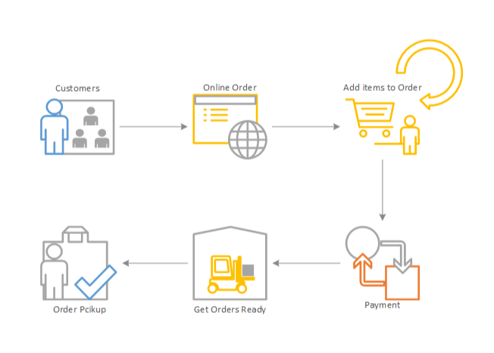

**Entity Relationship Diagram**

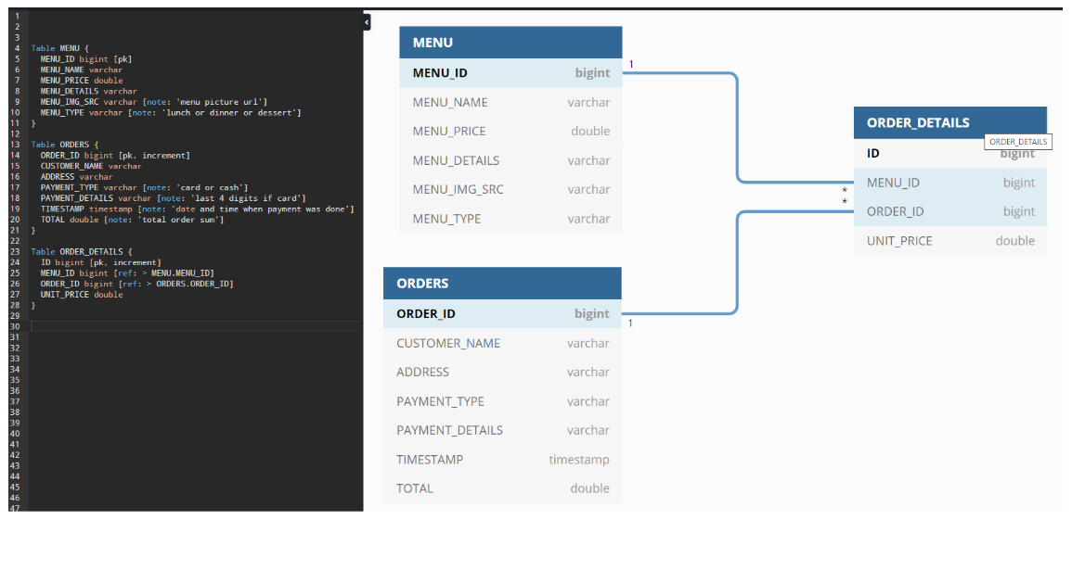

**Activity Diagram**

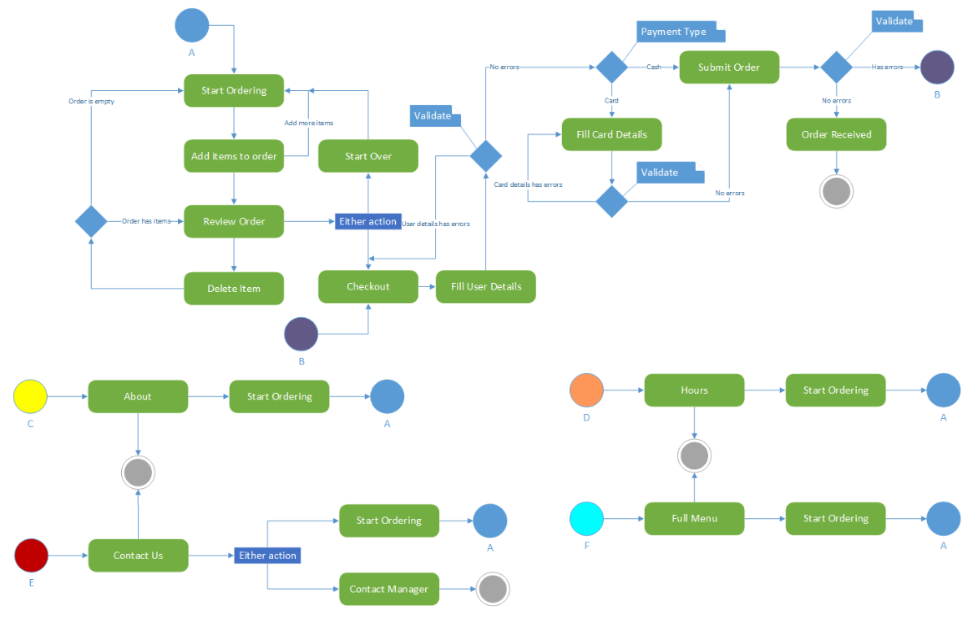

**UML Diagram**

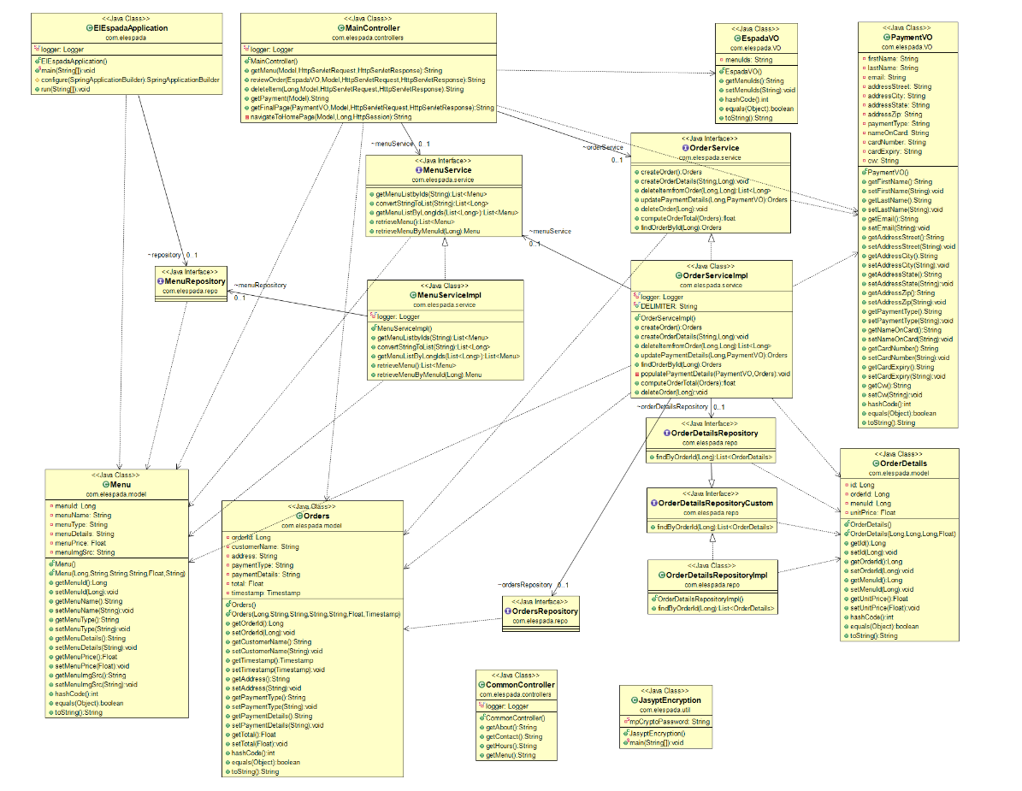

**Technical Document**



**Source Code Documentation**

**All source code can be found at the following GitHub repository:**

<https://github.com/zkparker/Software-Engineering-Capstone>

There is also an attached zipped folder of the source code that can be found below:



The source code contains comments throughout to help aid in tracing to requirements and to other components.

**Testing Documentation**

**Please see the attached document for the testing documentation:**



**Known Bugs and Issues**

**It is known that if a user adds items to their cart and then hits the back button in their browser, all items in the cart will be lost. Thus, making the user have to select each item again. It is also known that if a user forgets to add an item, they will need to start over or start or a new order for that missing item.**